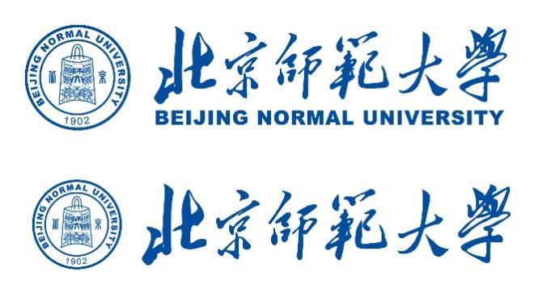

**2025 CAMPUS Asia Plus P2 Short-term Study Abroad Program at BNU (Tentative Program Schedule)**

**September 18-26,2025**

|  |  |  |
| --- | --- | --- |
|  | Date | Contents |
| Day 1 | Thursday  September 18th | Visiting students and staff leave home country for China (Beijing)  Check-in at accommodation  Pre-program session |
| Day 2 | Friday  September 19th | AM: Program Orientation and Campus tour  PM: Lecture (Chinese language and culture) |
| Day 3 | Saturday  September 20th | Practical activities (Field trip) |
| Day 4 | Sunday  September 21st | Practical activities (Field trip) |
| Day 5 | Monday,  September 22nd | AM: Lecture (Geography and sustainability)  PM: Lecture (Chinese education system) |
| Day 6 | Tuesday,  September 23th | Free day |
| Day 7 | Wednesday,  September 24th | AM: Lecture (Chinese education)  PM: Company visit |
| Day 8 | Thursday  September 25th | AM: Preparation for the final presentation  PM: Final presentation and wrap-up |
| Day 9 | Friday  September 26th | Visiting students and staff leave Beijing for home country |
| *This course will be conducted entirely in English.  *The program itinerary is subject to change. | | |